Version Control

Ques 1 Git Setup https://confluence.atlassian.

Commands
1. apt install git
2. git –version
3. git config –global user.name prateek1495
4. git config –global user.email prateek.nagar@tothenew.com

Ques 2 Initialize a Git Repository

Commands

1. create a directory in which initialize git.
2. git init

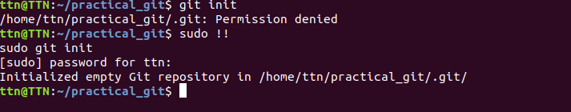

Ques 3 Add files to the repository

Commands

1. touch my.txt
2. touch file.txt
3. git status
4. git add .

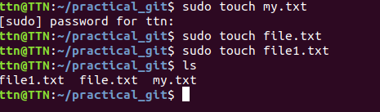

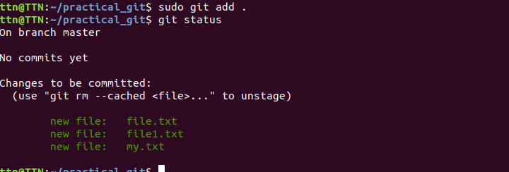

Ques 4 Unstage 1 file

Commands

1. touch file2.txt
2. git add .
3. git status
4. git reset HEAD
5. git status
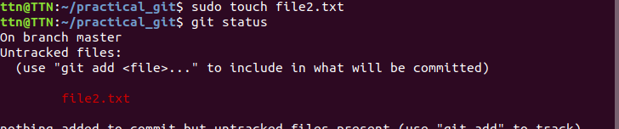
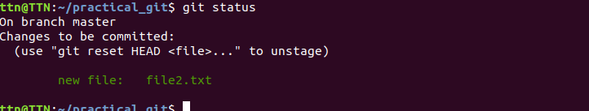
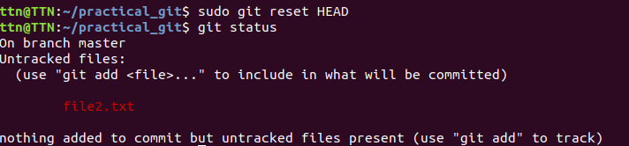

Ques 5 Commit the file

Commands

1. git commit -m”file2.txt commited”

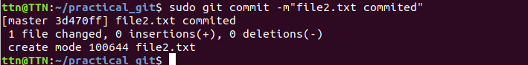

Ques 6 Add a remote

Commands

1. git remote add prateek-origin https://github.com/prateek1495/ttn_assignment.git
2. git remote -v

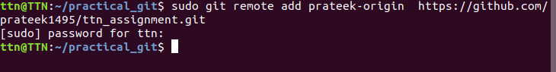

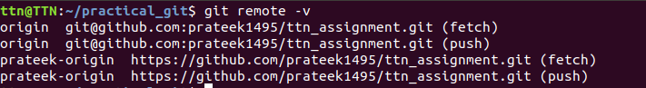

Ques 7 Undo changes to a particular file

Commands

1. vim file.txt
2. git status
3. git add .
4. vim file.txt
5. git checkout file.txt



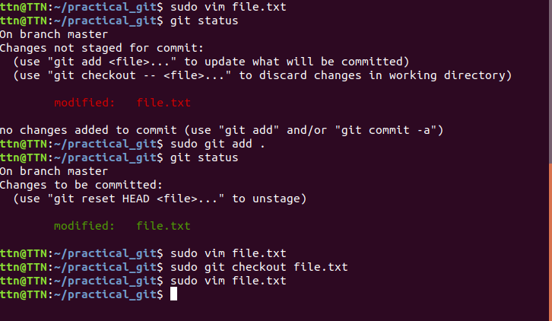

Ques 8 Push changes to Github

Commands

1. git push origin master

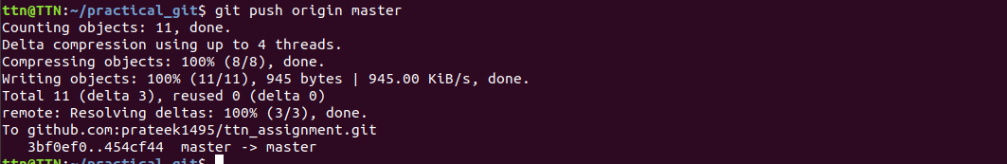

Ques 9 Clone the repository

Commands

1. git clone git@github.com:prateek1495/ttn_assignment.git

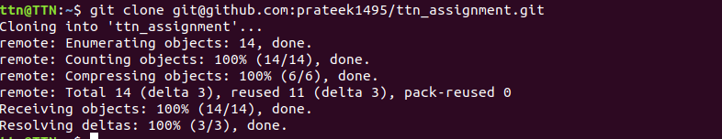

Ques 10 Add changes to one of the copies and pull the changes in the other.

Commands

1. vim file.txt
2. edit file
3. git status
4. git add .
5. git commit -m”file4.txt edited”
6. git push origin master
7. git pull origin prateek_branch

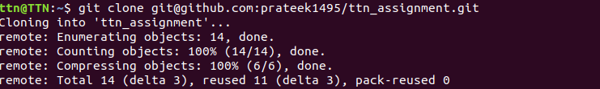
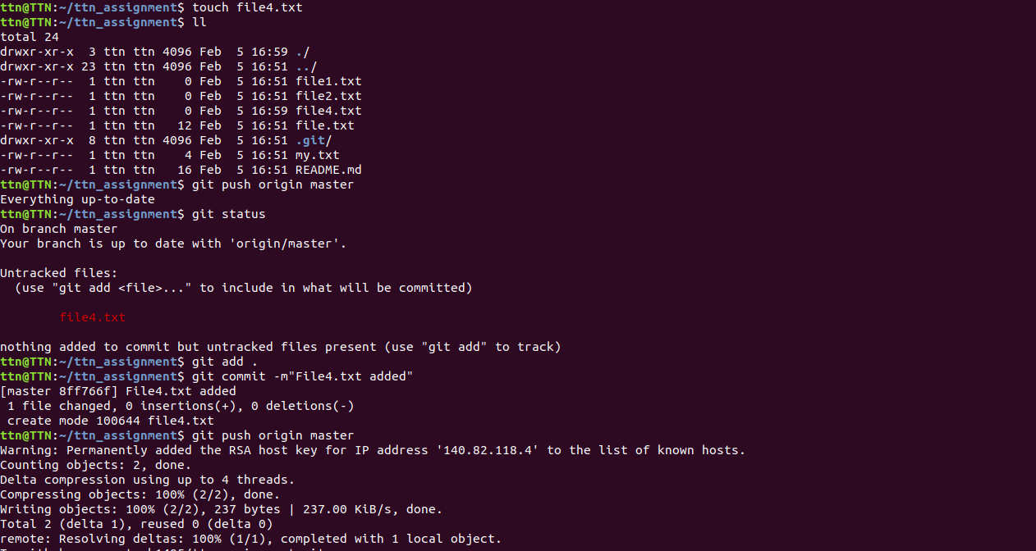

Ques 11 Check differences between a file and its staged version

Commands

1.vim file5.txt
2. git status
3. git add .
4. git diff --staged

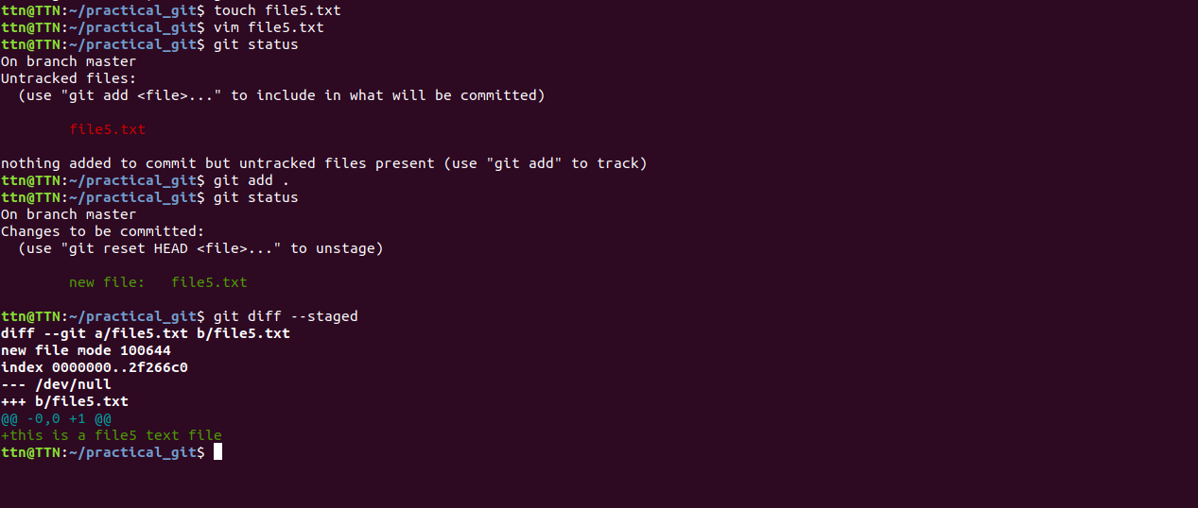

Ques 12 Ignore a few files to be checked in

Commands

1. touch prateek.txt
2. touch prateek.html
3. touch target
4. git status
5. vim .gitignore
6. add *.html in .gitignore
7. git add .
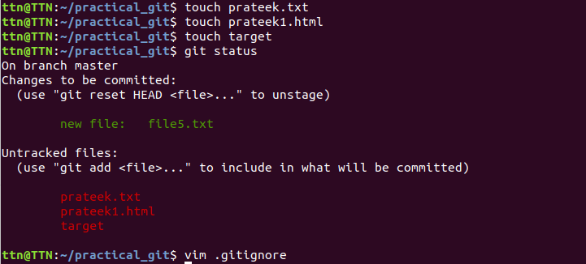
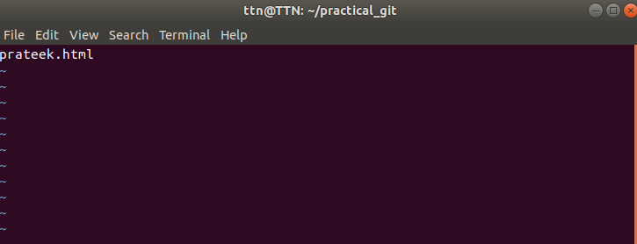

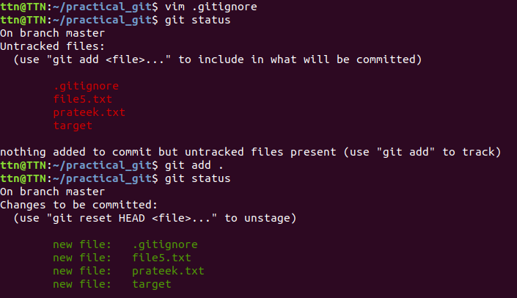

Ques 13 Create a new branch.

Commands

1. git branch
2. git checkout -b prateek_branch

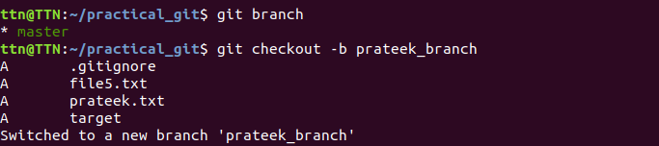

Ques 14 Diverge them with commits

Commands

1. git checkout -b prateek1
2. vim ttn
3. git status
4. git add .
5. git commit -m”prateek1 ttn commit”
6. git push origin prateek1
7. git checkout -b prateek2
8. vim ttn
9. git status
10. git add .
11. git commit -m”prateek2 ttn commit”
12. git push origin prateek2

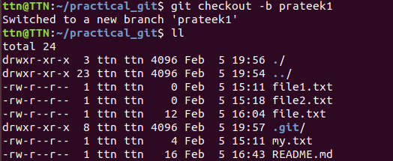
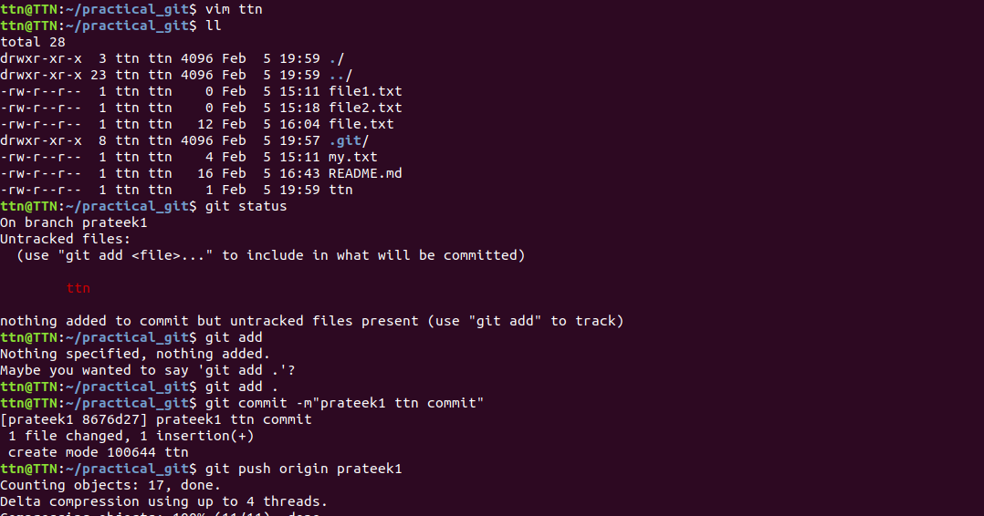
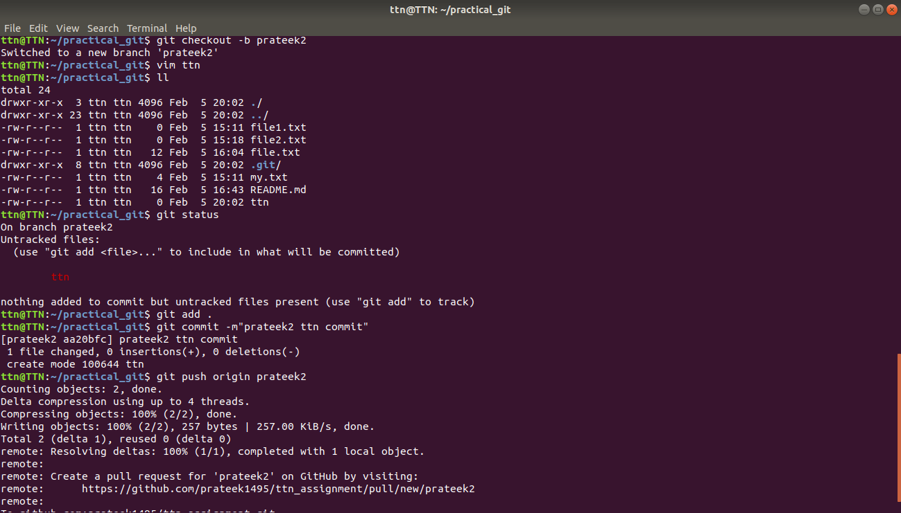

Ques 15 Edit the same file at the same line on both branches and commit

Commands

1. git checkout prateek1
2. vim ttn
3. edit the file
4. git status
5. git add .
6. git commit -m”prateek1 file edited”
7. git push origin prateek1
8. git checkout prateek2
9. vim ttn
10. edit the file
11. git status
12. git add .
13. git commit -m”prateek2 file edited”
14. git push origin prateek2

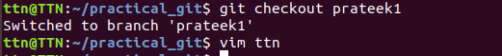

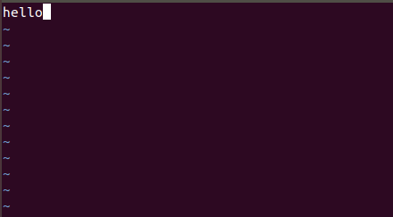


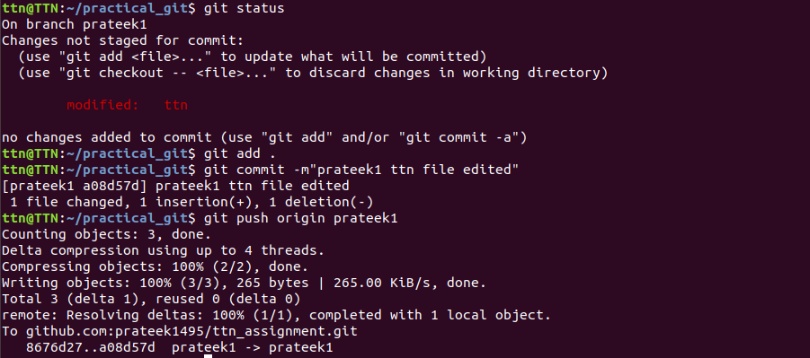
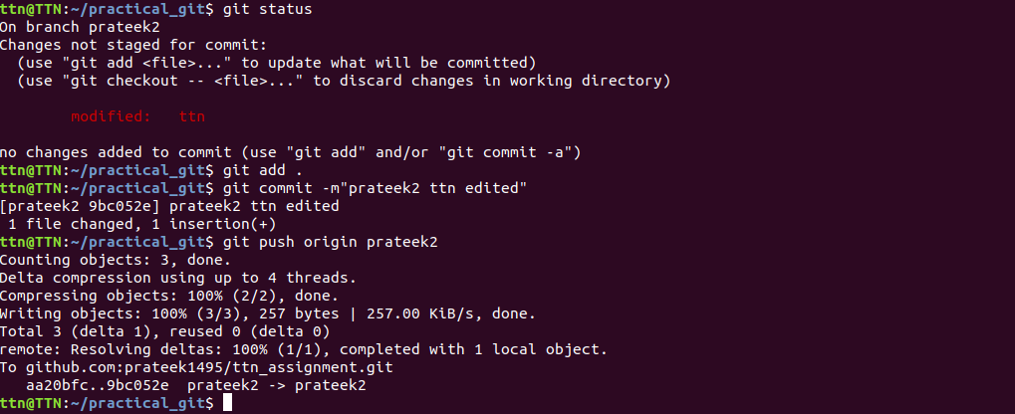

Ques 16 Try merging and resolve merge conflicts

Commands

1. git checkout prateek2
2. git merge –no-ff prateek1
3. vim ttn
4. git commit -am”merged”
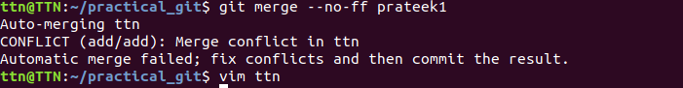
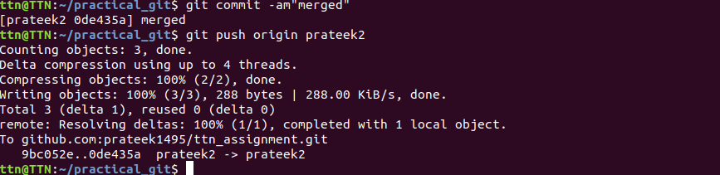

Ques 17 Stash the changes and pop them

Commands

1.git checkout prateek_branch
2. vim assignment
3. git status
4. git add .
5. vim assignment
6. edit file
7. git stash
8. git stash list
9. git stash pop

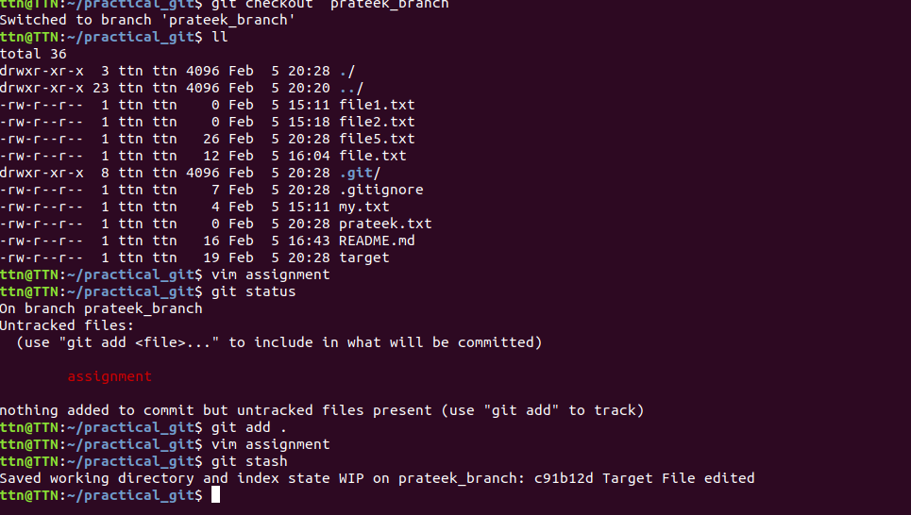

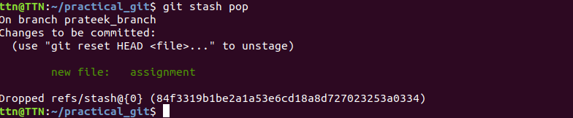

Ques 18 : Add the following code to your .bashrc file : color_prompt="yes"
parse_git_branch() {
git branch 2> /dev/null | sed -e '/^[^*]/d' -e 's/* \(.*\)/(\1)/'
}
if [ "$color_prompt" = yes ]; then
PS1='\u@\h\[\033[00m\]:\[\033[
else
PS1='\u@\h:\W $(parse_git_branch)\$ '
fi
unset color_prompt force_color_prompt

